2023 AAUW IL CONVENTION SPEAKERS

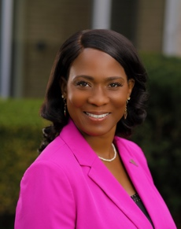
Dr. SHARON DESMOULIN-KHERAT, since 2015, has served as superintendent of Peoria Public Schools, an Illinois district with 27 schools and 13,000 students. Dr. Kherat’s 2022-2023 vision for Peoria Public Schools is reimagining schools to ignite students’ passions and empower students to be responsible and successful.

Prior to her current role, Dr. Kherat served the district as a middle-school teacher, assistant principal of Roosevelt Magnet School, and principal of Whittier Primary and Manual High School. During her tenure at Whittier, it was named a national Blue Ribbon School, defying the odds as a high-performing, high-poverty school—one of her life’s proudest achievements. Dr. Kherat also served as associate superintendent of Danville District 118 and as a transformation officer in Springfield Public Schools.

Originally from Dominica, West Indies, and St. Croix, U.S. Virgin Islands, Dr. Kherat completed her bachelor’s and master’s degrees at Bradley University before earning her education doctorate (Ed.D.) in P-12 administration from Illinois State University.

Dr. Kherat was named a 2021 Regional Superintendent of Distinction by the Illinois Association of School Administrators (IASA) based on her leadership, communication, professionalism and community involvement.

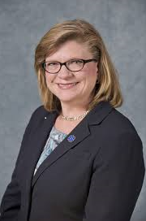
Dr. SHEILA QUIRK-BAILEY joined Illinois Central College in July 2016. She brings more than 32 years of community college experience to her role at ICC and is committed to providing educational opportunities in Central Illinois.

Dr. Quirk-Bailey is passionate about engaging the community, aligning programs and services, meeting individuals where they are and realizing high levels of outcomes for our students, their families, the workforce and our regional economy. Her interests include working through an equity lens to increase college and career readiness in high school students, to provide supports and programs to credential people of poverty and to align employer’s available jobs with a credentialed workforce.

Dr. Quirk-Bailey holds a Doctorate in Management in Community College Policy and
Administration from the University of Maryland, a Master’s degree in Communications from
Northern Illinois University, and a Bachelor of Science degree in Speech Communication from
Bradley University.

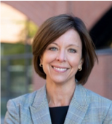
Dr. Jennifer Robin, Ph.D. brings a unique blend of skills and experiences to her coaching and consulting engagements. She is a psychologist, certified Life Design coach, and an expert in leadership development, organizational culture, and strategic human resource management. During her career, Jennifer has served as a trusted advisor to leaders and leadership teams, designed and delivered academic curricula, managed operations in higher education, and led a School of Business as its dean.
Jennifer has built a thriving coaching and consulting practice over 25 years and is recognized as an expert in great workplaces. She is a former Senior Consultant and Advisory Practice Lead at Great Place to Work® Institute, and she has coauthored three books – No Excuses: How You Can Turn Any Workplace into a Great One (2013), The Great Workplace: How to Build It, How to Keep It, and Why It Matters (2011) and A Life in Balance: Finding Meaning in a Chaotic World (2006).
Jennifer is currently a Professor of Management in the Foster College of Business at Bradley University. Previous to her reappointment in 2021, she served as the Dean of the School of Business at Southern Connecticut State University and Associate Dean at Bradley University
Education, Certifications, Memberships
- Ph.D. in Industrial/Organizational Psychology from the University of Tennessee
- Certification in Life Design® Coaching and Strategic Doing™ Workshop Leadership
- Society for Industrial and Organizational Psychology
- American Psychological Association
- Academy of Management

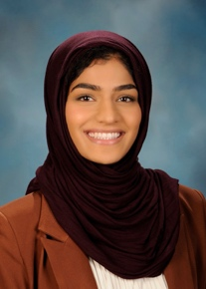
Nabeela Syed is proud to represent the 51st District of the Illinois State House of Representatives, serving the communities of Palatine, Inverness, Barrington, Hoffman Estates, Rolling Meadows, Lake Zurich, Hawthorn Woods, Kildeer, Deer Park, Vernon Hills, and Long Grove.
Nabeela previously worked for a non-profit in digital strategy supporting a variety of their civic engagement efforts including voter mobilization, ending sexual assault on college campuses, and promoting gender equity; mentored for youth as a high school debate coach; is active in her community Islamic Society of Northwest Suburbs.
In the legislature, Nabeela will work to champion property tax relief, gun safety, healthcare affordability, and more.
B.A. in Political Science and Business Administration, University of California, Berkley.
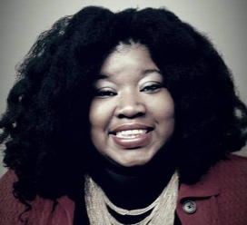
Nabeela was born and raised in Palatine, Illinois.
Crystal Owney, MBA, graduated from University of Wisconsin- Milwaukee in 2010 with a BBA in Finance. During her junior year in college she studied International Finance at Auckland University of Technology in Auckland, NZ. In 2012 Owney earned a graduate certificate in ERP IT from the University of Wisconsin- Milwaukee. In 2015 Owney completed her MBA in Finance with an emphasis in Mandarin from the Lorry I Lokey GSB at Mills College. While at Mills College Owney was the college's first African American to receive the prestigious Selected Professions Fellowship from AAUW. She was also the college's first student to receive a paid internship with AT&T through their very competitive Finance Leadership Program.

Owney has worked for BMO Harris bank(formerly Marshall & Islley), Quarles and Brady, Johnson Controls, Harley Davidson, SEO Scholars of San Francisco and GE Aviation. Currently, she works at Hub Group, Inc as a Financial Analytics Manager. This summer she had an amazing opportunity to speak with high schools girls around the world about careers in STEM through AAUW STEMed Program.

Owney currently resides in Itasca, IL. She sits on the Board of Directors for Lad Lake, Inc and is a new member to AAUW- Schaumburg branch. As a proud orphan of the State of Wisconsin and foster child of over 14 homes and shelters, she says her success is through her mothers, dads, aunts, mentors, Lad Lake, Inc, Marquette University Upward Bound Program, Ronald McNair Scholars Program, and INROADS, Inc.

